**LAB 3 – Part 1 (8 points)**

Create this amplitude modulation synthesizer below using the file “Lab3 - Part 1-DEMO.maxpat.”

Follow the class demonstration video and the comments within the patch to guide you.

Here is the link to the video demonstration:

https://media.ucsc.edu/V/Video?v=4151880&node=14192515&a=41192805&autoplay=1

**Due: turn in a screen shot of your finished patch and name it as follows: “lastname firstname lab 3 part 1”**

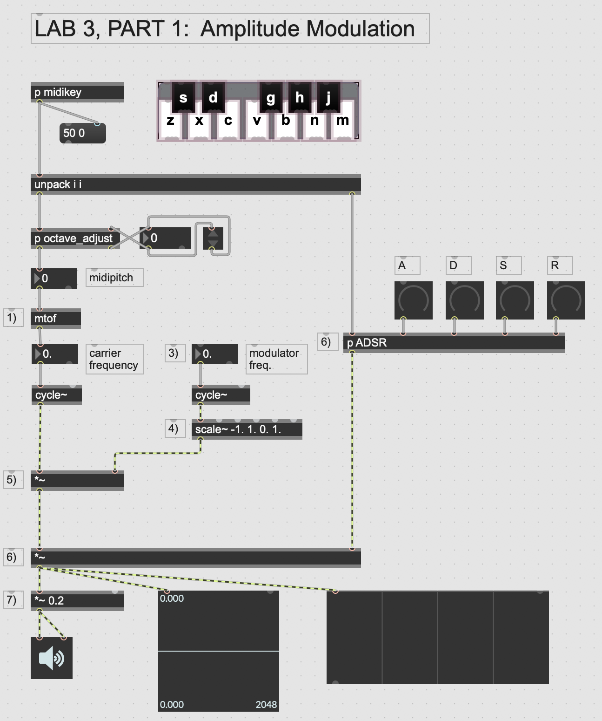

**LAB 3 – Part 2 (8 points)**

Create this fm synthesizer below using the file “Lab3-Part 2-DEMO.maxpat”

Follow the class demonstration and the comments within the patch to guide you.

Here is the link to the video demonstration:

https://media.ucsc.edu/V/Video?v=4152465&node=14195691&a=116858120&autoplay=1

**Due: turn in a screen shot of your finished patch and name it as follows: “lastname firstname lab 3 part 2”**

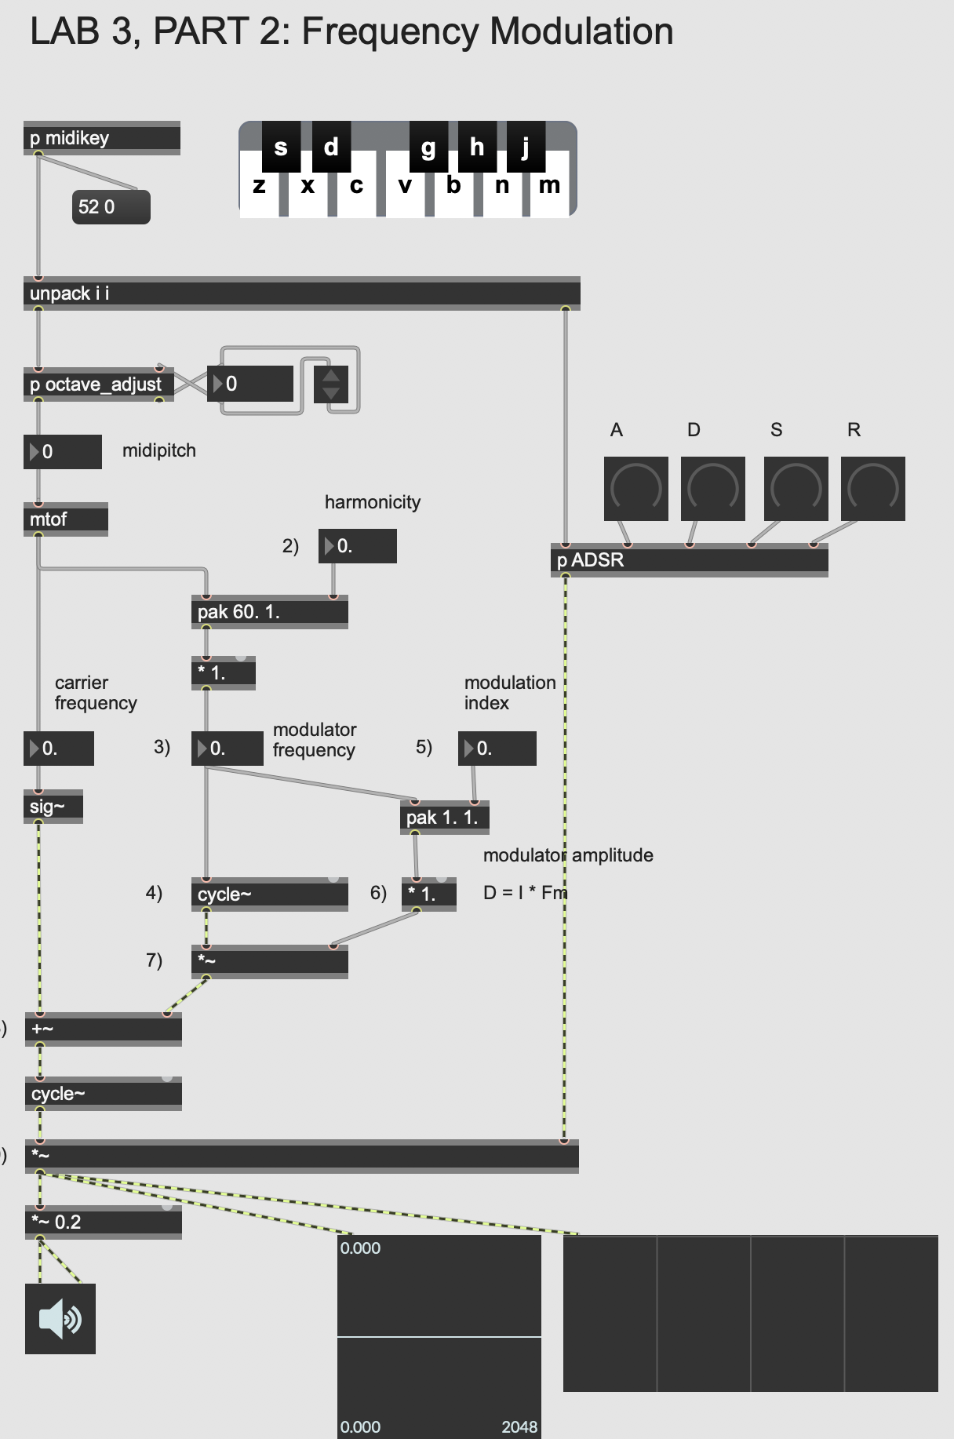

**LAB 3 – Part 3 (4 points)**

Add four voices of polyphony to you fm synthesizer below using the file “Lab3-Part 3-DEMO.maxpat”

Follow the video demonstration and the comments within the patch to guide you. Here is the link to the video demonstration:

https://media.ucsc.edu/V/Video?v=4153840&node=14203038&a=43001891&autoplay=1

Make these three screenshots below to demonstrate your progress

**1) Due: turn in a screen shots of your finished patch and name it as follows: “lastname firstname lab 3 part 3-1”**

The fm synthesis subpatch view

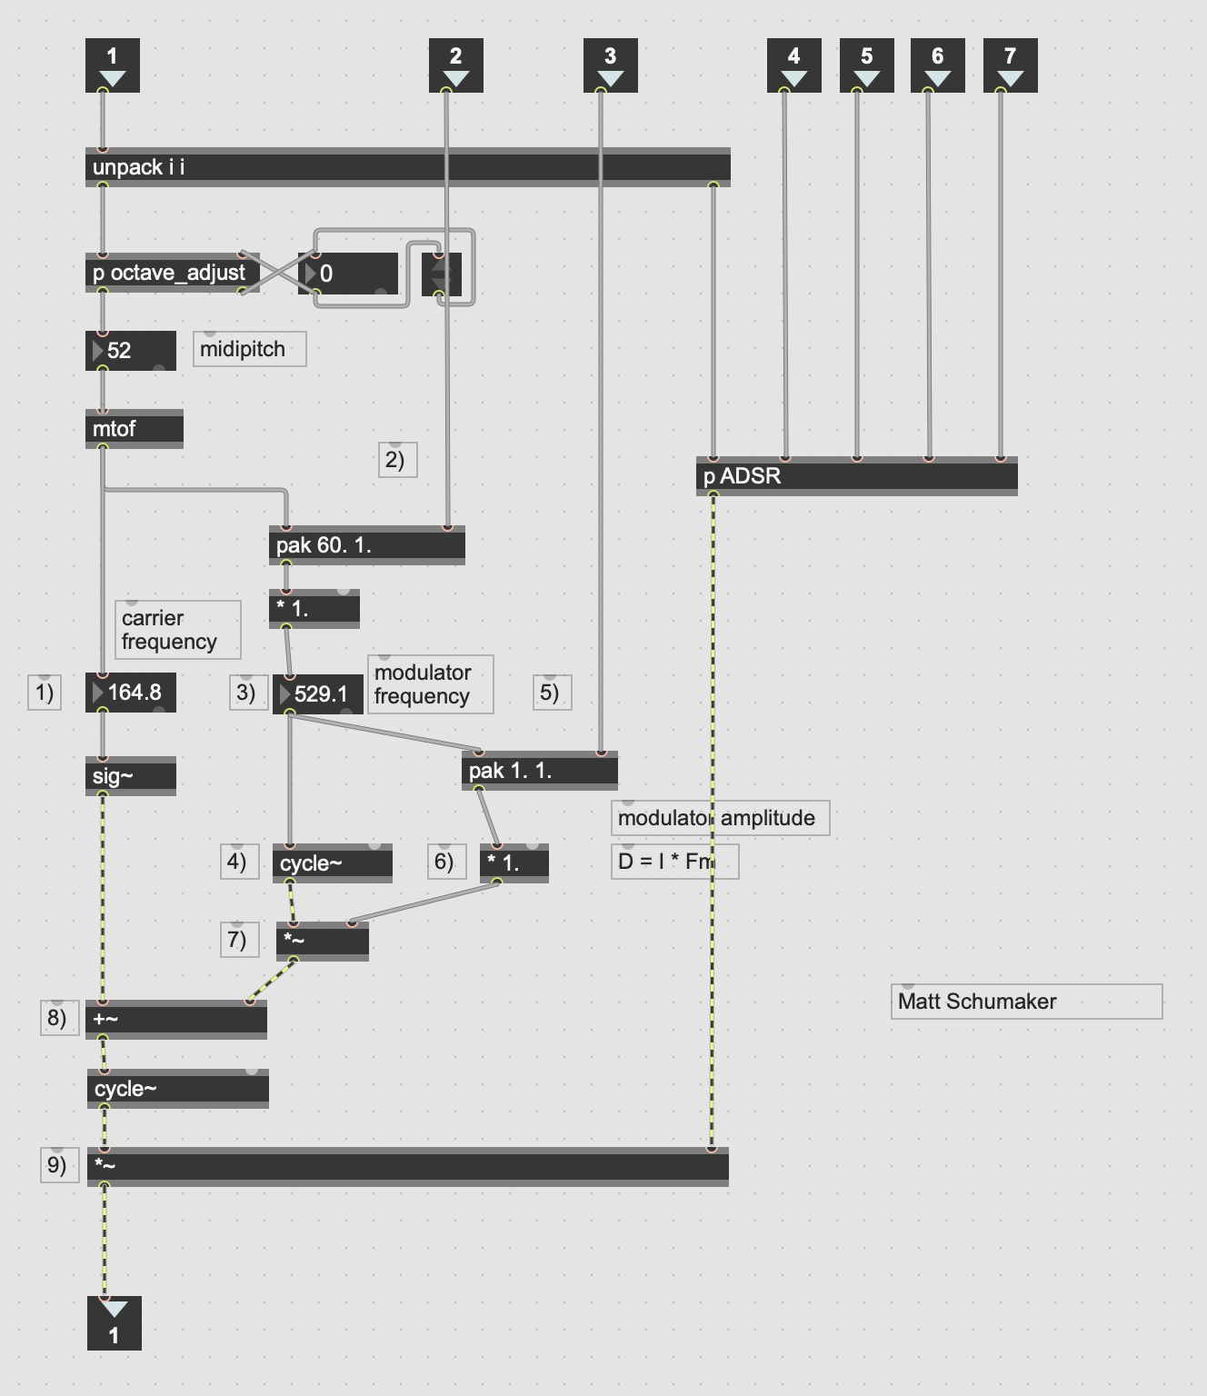

**Due: turn in a screen shots of your finished patch and name it as follows: “lastname firstname lab 3 part 4-2”**

4-part polyphony working in the fm synthesis patch

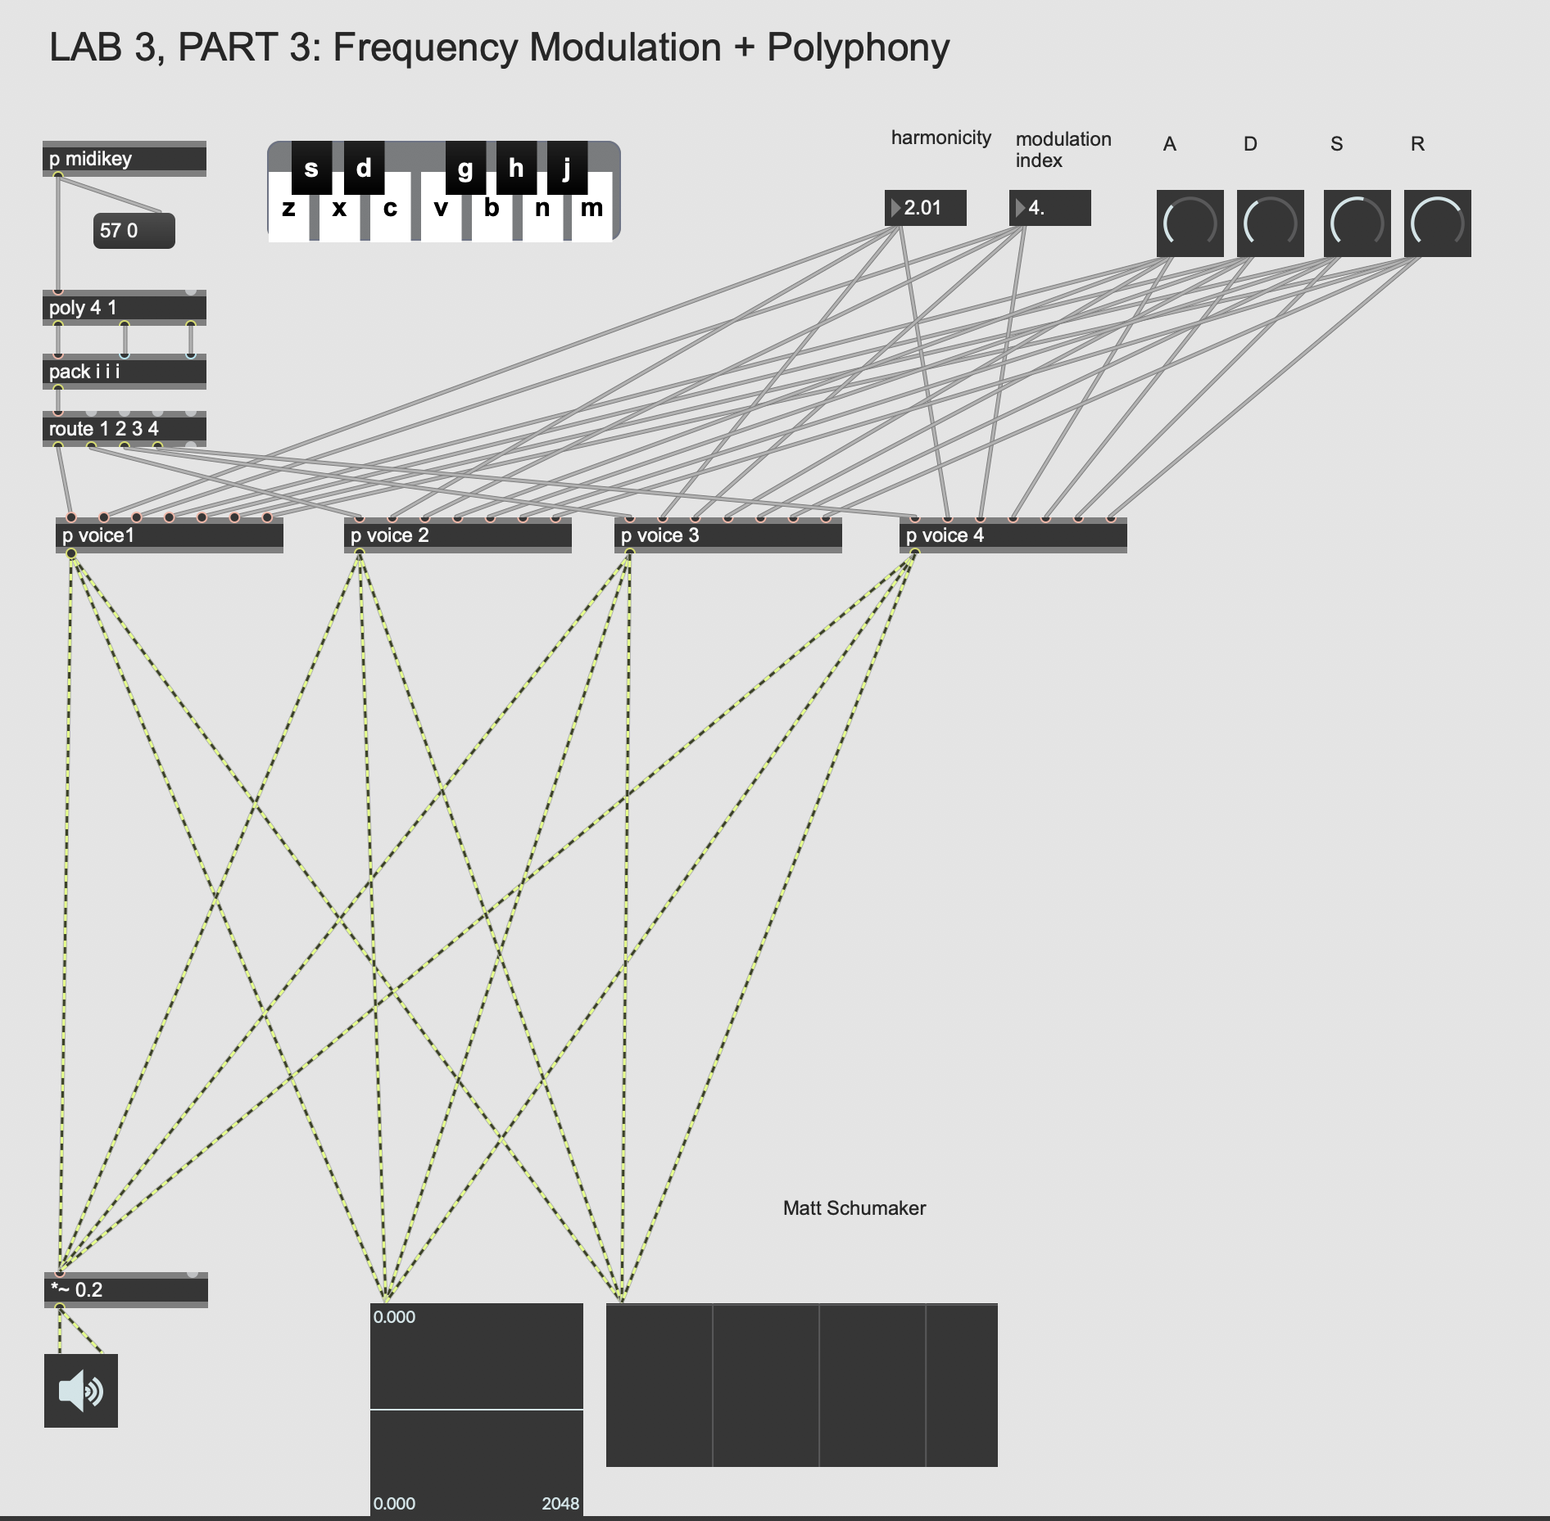

**Due: turn in a screen shots of your finished patch and name it as follows: “lastname firstname lab 3 part 4-3”**

Presentation view

